Peak Petroleum Industries Nigeria LTD
and
Equator Exploration Nigeria LTD

Offshore Nigeria Block OML 122

Bilabri D3
Appraisal Well
Revision 0

Well Plan Summary
For
Jetting 36” Conductor
and
Setting 20” x 13-3/8” Surface Casing

Drilling Unit
Semisubmersible Bulford Dolphin

Table of Contents

- Introduction
- Location Maps
- Basic Well Data
- Well Plan Outline
- Operation Summary
- Days vs Depth Curve
- Drilling Time Breakdown
- Rig Move
- Fracture Gradient / Pore Pressure
- Pressure Profile vs Depth
- Casing Program Summary
- Cement Program Summary
- Mud Program Summary
- Directional Survey Program Summary
- Formation Evaluation Summary
- Operational Procedures
Jetting 36” Conductor
Drilling 17-1/2” Hole Section Riserless
Setting 20” x 13-3/8” Surface Casing

Signature Approvals:

Written By: ___________________________ Date: __________
Robert Montgomery
Drilling Project Manager – Beta Development Team

Reviewed By:___________________________ Date: __________
Bobby Roundtree
Drilling Superintendent – Beta Development Team

Approved By: ___________________________ Date: __________
Glyn Evans
Project Director – Beta Development Team

Approved By: ___________________________ Date: __________
Dr. Kenneth Seymour
Project Adviser – Beta Development Team

1. Introduction

Following the well results of Bilabri D2 well, which found the C1 sand 48m higher than prognosed and consequently found the C1 sand gas bearing, the consensus is that structural control of the Bilabri structure is uncertain. This is basically due to the conflicting evidence between the seismic structural map and the amplitude anomaly map.

The seismic depth maps show a very irregular structure with steep N-S trending ridges and valleys, while the amplitude map suggests a more gentle structure.

An additional point of uncertainty is the mismatch between the Bilabri-2 well with the seismic: while Bilabri-1, Bilabri Deep1 and Bilabri D2 well tie-in with the seismic, the Bilabri-2 well is 48m deep, indicating a subtle velocity-change along the dip direction. Although oil has been encountered only in the C2 sand, possibility exists that oil is also present in the overlying C1 sand based on geological, and pressure arguments, with an oil-water contact at 2412m ss.

The eastern flank of the Bilabri structure remained un-drilled, but could contribute considerably additional volumes for the proven oil volumes in the C2 sand or may prove additional oil volumes in the C1 sand.

It is proposed to drill the appraisal/production well Bilabri D3 as an appraisal well at the eastern flank of the Bilabri structure, targeted at the C sands. The objectives of the proposed well is to prove the potential upside of the C2 sand and prove/disprove the presence of oil in the C1 sand.

The Bilabri D3 well is proposed to be a vertical well with a TD of 2500m.
The well could be deviated later into another appraisal well of a producer at the C1 or C2 sand level.

Spud-date of the well is scheduled to be in September 2006.

The field is located in water depth of approximately 145m, and approximately 50 km offshore.

2. Location Maps

Regional Location Map
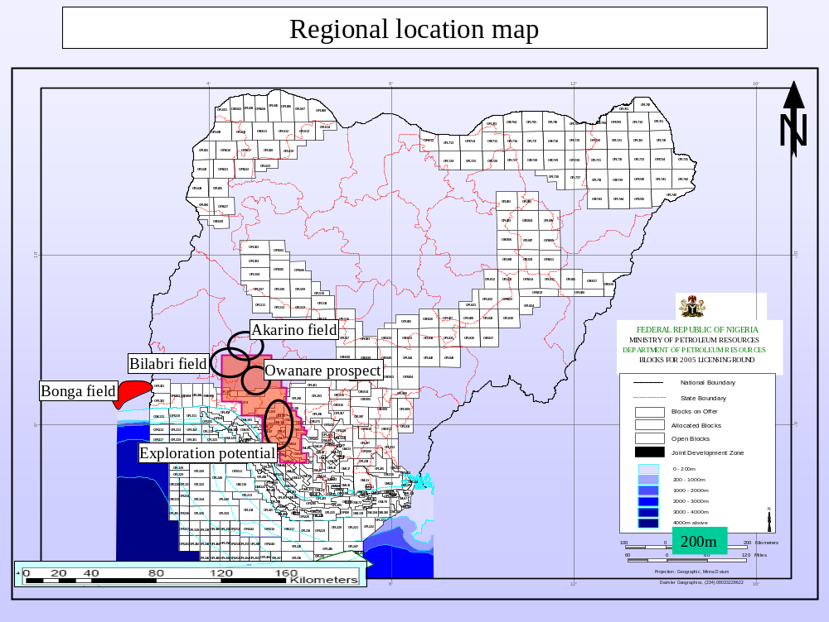

OML 122 Lease Map

To Be Inserted
3. Basic Well Data

Well Name: Bilabri D3
Designation: Appraisal Well
Concession: OML 122
Depo Basin: Offshore Niger Delta
Offshore Field: Bilabri Field

Operator: Peak Petroleum Industries Nigeria LTD
Partner: Equator Exploration Nigeria LTD
Anticipated Spud Date: October 2006

Rig: Bulford Dolphin
Rig Contractor: Dolphin Drilling
Rig Type: Aker H3 Semisubmersible

Water Depth: 145 meters
RKB to Mean Sea Level: 25 meters
RKB to Mudline: 170 meters

Surface Location: Lat: 04º 39’ 40.334” N
Long: 05º 05’ 23.851” E
X = 731,847.10 E
Y = 515,558.23 N

Projection: UTM Zone 31N
Spheroid: WGS 84
Datum: WGS 84
Type: Transverse Mercator
Central Meridian: 3.0E
Scale Factor: 0.9996
False Northing: 0.00 meters
False Easting: 500,000 meters
Zone 31

Objectives: Appraise Oil Rim in C1 Main Gas Sand

Casing Setting Depths (RKB): 36” @ 242m (72m below mudline)
20” x 13-3/8” @ 1100m (930m below mudline)
9-5/8” @ 2500m TVD MD – If Required for Testing

Programmed Days: 24.5 days to drill to TD of 2500m Vertical
And Temporary Abandon

Total Depth: 2500m TVD / 2500m MD RKB

4. Well Plan Outline
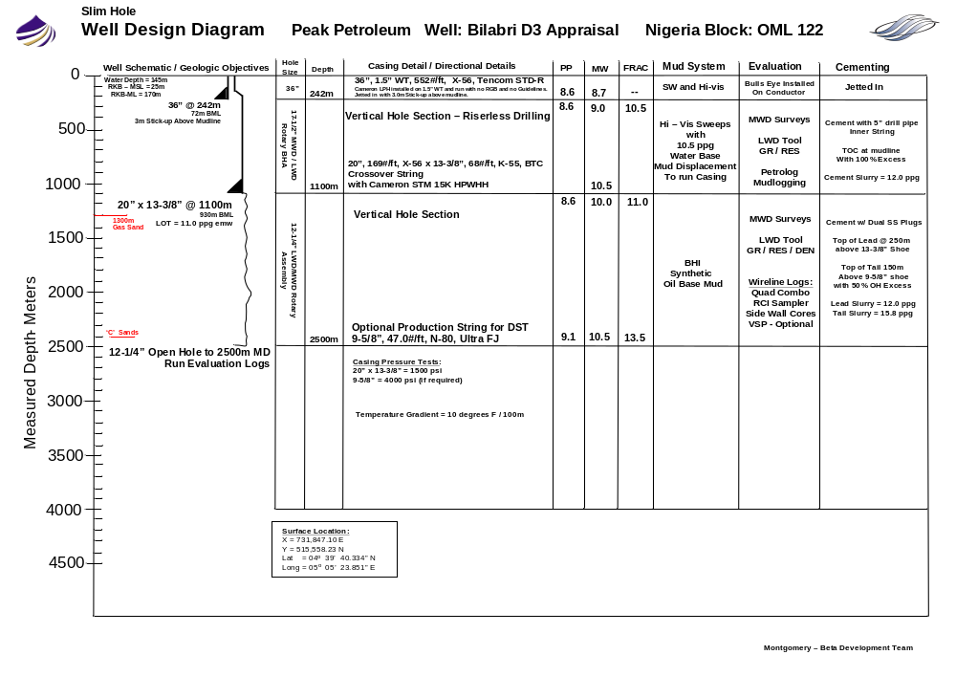
Well Profile Diagram
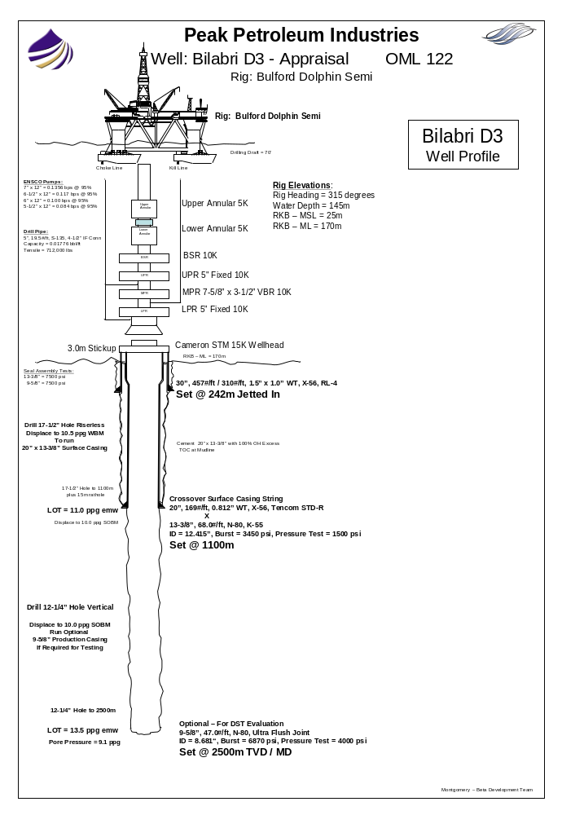
5. Operations Summary

Bilabri D3 Well Location Coordinates
The Bulford Dolphin Semi will be moved from the Bilabri D2 Well to the Bilabri D3 Appraisal Well using (2) AHTS vessels on contract to Peak/Equator. The anchors will be run as per Dolphin Rig Move Procedures with a proposed rig heading of 315 degrees. The water depth at the Bilabri D3 location is 145m.

The Bilabri D3 Surface Location Coordinates are as follows:
X = 731,847.10 East
Y = 515,558.23 North
Lat = 04º 39’ 40.334” North
Long = 05º 05’ 23.851” East

Setting 36” Conductor @ 242m RKB
The well will be spudded with a 36” Conductor / Jet String. The 36” Conductor String will be jetted to 242m RKB (72m below mudline) with maximum hole angle of 1 degree with 3m stick-up above mudline. The conductor will be jetted using hi-vis sweeps made from guar gum and polymer (no bulk bentonite in Nigeria) and a jetting BHA Assembly consisting of a 26” bit and
9-1/2” OD Mud Motor. The conductor will be allowed to soak 4 to 6 hours before releasing the Cameron Running Tool and pulling the jetting BHA. The 36”, 1.5” WT, 552#/ft, X-56, Tencom STD-R casing will be run with the Cameron Low Pressure Housing and no RGB and no guidelines attached. All efforts will be made to keep the 36” housing angle at 1 degree or less. If the casing is jetted in at an angle greater the 1.5 degrees, the conductor will be washed free and the conductor repositioned and re-spudded.

Setting 20” x 13-3/8” Surface Casing @ 1100m RKB
The 17-1/2” hole section will be drilled with a 17-1/2” MWD/LWD Rotary Assembly. The hole section will be drilled riserless with returns to the mudline through the 30” LPH. The 17-1/2” hole will be drilled to 1100m (depending on pipe tally plus 5m of rathole). The hole will be drilled riserless using hi-vis sweeps made from guar gum and polymer. The hole will be displaced to 10.5 ppg mud before running the 20”x 13-3/8” Casing. Cameron STM 18-3/4” 15K H-4 high pressure housing will be run with 2 joints of 20”, 171#/ft, 0.812” WT, X-56, Tencom STD-R and then crossed over to 13-3/8”, 68#/ft, K-55, BTC surface casing string. The 20” and 13-3/8” casing will be run using side door elevators and slips. The casing will be cemented using a float collar and using a (2) joint shoe track above the float shoe. The casing will be cemented using 100% open hole excess on cement slurry volume with the TOC at mudline using 5” drill pipe inner string positioned 40m above the float collar during cement placement. Use a drill pipe wiper dart to displace cement thru the 5” drill pipe cement stinger. Displace cement to 20 meters above 13-3/8” Float Collar.

Setting 9-5/8” Production Casing @ 2500m TVD/MD RKB – If Required for Testing
The SS BOP will be run without guidelines and RGB. The ROV will assist in latching the H-4 connector on BOP to Cameron’s 18-3/4” HPH. The 20” x 13-3/8” casing will be pressure tested to 1500 psi before drilling out. The casing will be displaced to SOBM and drilled out using a slick 12-1/4” BHA. A LOT will be performed to 11.0 ppg emw. The slick assembly will be pulled. A rotary assembly with MWD/LWD will be run in and the 12-1/4” hole section will be vertically drilled to 2500m RKB. The mud weight will be controlled as required to maintain hole stability and limit overbalance to formation pressure. The 9-5/8”, 47.0#/ft, N-80, Ultra FJ casing will be run if required for testing. The 9-5/8” will be cemented with the top of lead cement at least 150m above the 13-3/8” shoe using 50% open hole excess. The well will be temporarily suspended for later re-entry to install the Cameron Horizontal Spool Production Tree and the 4-1/2” tubing completion.
6. Days vs Depth Curve

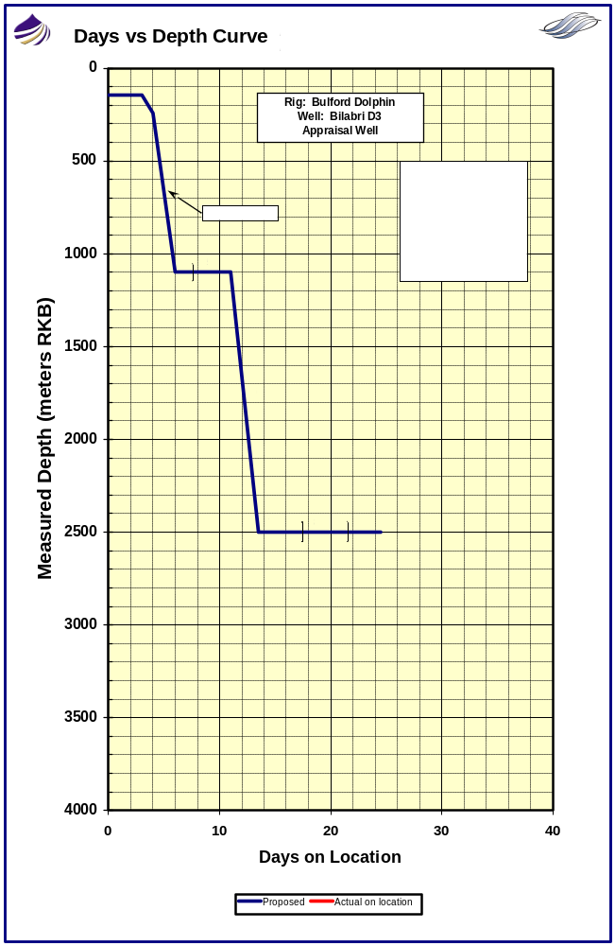
7. Drilling Time Breakdown

Operation Activity | Days | Cum Days
Jet in 36" Conductor. Set 20" x 13-3/8" Surface Casing.
Move "Bulford Dolphin Semisubmersible" to location and confirm position. | 1.0 | 1.0
Run anchors and pre-tension. Ballast to drilling draft. | 2.0 | 3.0
Spud Well. Jet in 36", 1.5" WT Conductor at 242m. Release Cameron Running Tool. POOH. | 1.0 | 4.0
Drill 17-1/2" hole section riserless to 1100m. Displace to 11.0 ppg WBM. Wiper Trip. POOH. | 2.0 | 6.0
Set 20" x 13-3/8" Surface Casing w/ 18-3/4" Cameron HPWHH. WOC. POOH w/ RT. | 1.5 | 7.5
Run and test 18-3/4" BOP stack. | 1.5 | 9.0
Drill out 20" x 13-3/8" casing. Displace to SOBM. LOT. POOH. | 1.0 | 10.0
Total Days | 10.0
Drill 12-1/4" Evaluation Hole to 2500m.
MU 12-1/4" LWD / MWD Rotary BHA. RIH. | 1.0 | 11.0
Drill 12-1/4" Vertical Evaluation Hole from 1100m to 2500m MD (1600m @ 25m/hr). | 2.5 | 13.5
Condition hole to run Baker Atlas Open Hole Logs. POOH with LWD BHA. | 1.0 | 14.5
RU Baker Atlas. Run Open Hole Evaluation Logs. (Quad Combo, SWC, and VSP - Optional). | 3.0 | 17.5
Total Days | 7.5
Plug Back Open Hole. Temporary Suspend.
RIH with 5" Drill Pipe. Circulate and condition mud. | 1.0 | 18.5
Set Cement Plugs for Temporary Abandonment. Displace to WBM. | 3.0 | 21.5
Pull SS BOP. LD Drill Pipe. Pull Anchors. Release Rig. | 3.0 | 24.5
Total Days | 7.0
Total Days on Well |  | 24.5

8. Rig Move

The contracted AHTS vessels will move the Bulford Dolphin Semi from the Bilabri D2 location. Fugro navigation equipment and personnel on board the rig will be utilized to verify the rig’s final position at Bilabri D3 Location. The rig’s final heading will be positioned at 315 degrees. (To be verified with Dolphin’s OIM).

Bilabri D3 Well Surface Location Coordinates:
Lat: 04º 39’ 40.334” N
Long: 05º 05’ 23.851” E

X = 731,847.10 E
Y = 515,558.23 N

The water depth at the Bilabri D3 location is 145 meters. An 8-point mooring system will be utilized. The rig move will be based on the Dolphin Rig Move Procedure. The Dolphin Barge Captain will decide the running order of the anchors as per the Rig Move Procedure and after discussion with the captains of the anchor handling vessels and Peak Drilling Supervisor.

Anchors are to be tensioned to Dolphin specifications after adequate soak time is allowed. Experience from offset wells indicates that anchoring will not be a problem.

A meeting will be held with workboat captains and with Dolphin rig personnel on anchoring procedures.

Crews on board the workboats will enable a full 24 hour anchoring operation to be carried out.

Send in Fugro Preliminary Position Report to PHC and Lagos Office, once anchored up, and at final spud position. Attempt to position the rig to within 3 meters of proposed surface location.

A site survey has been performed and no risks have been identified. (Survey not on the actual location area).

After the rig has run anchors and ballasted down, the ROV will perform a seabed survey of 100 meters around the proposed well location.

Anchoring operations description in the Daily Drilling Report should state the following times:
PCC passed to boat, anchor on bottom, PCC passed back to rig.

Anchoring Pre-Tension Value should also be reported.

9. Fracture Gradient / Pore Pressure

Historic data from offset wells show that low fracture gradients are common in Block 122. Fracture gradients are estimated from offset well data and adjusted for water depth.

It is anticipated that the following casing shoe leak-offs will be achieved
(all depths are meters RKB):

Shoe Depth | Hole Size (in) | Hole TD  (m TVD/MD) | LOT (ppg) | MW  (ppg) | Pore Pressure (ppg)
20” x 13-3/8”  @ 1100m | 17-1/2” | 1100/1100 | 11.0 | 10.5 | 8.6
-- | 12-1/4” | 2500 | -- | 10.5 | 9.1

10. Pressure Profile vs Depth
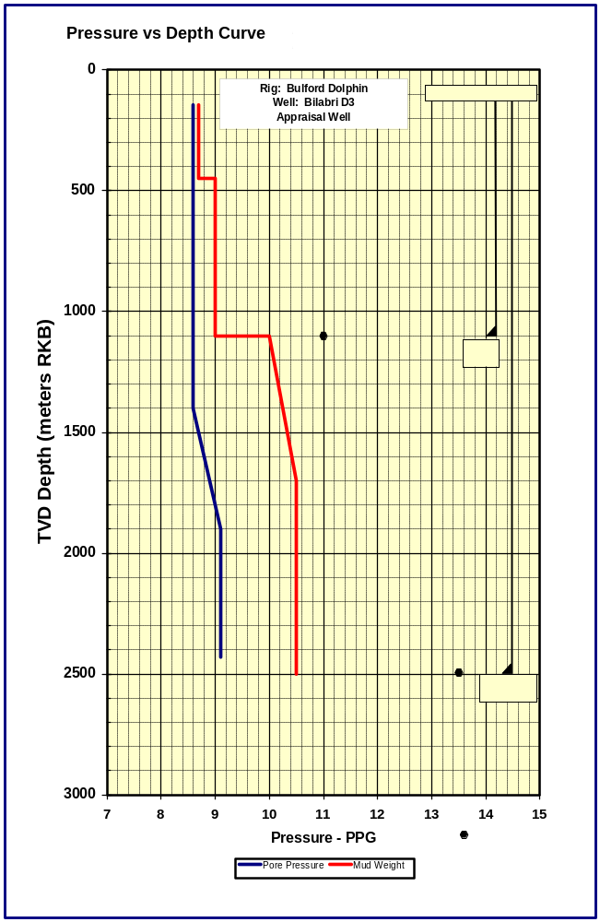
11. Casing Program Summary

The following table provides a summary of the selected casing setting depths and material specifications.

Casing Size (in) | 36” | 20” | 13-3/8” | 9-5/8”
Weight (#/ft) | 552 | 169 | 68.0 | 47.0
Grade | X-56  1.50” WT | X-56  0.812” WT | K-55 | N-80
Connection | Tencom STD-R | Tencom STD-R | BTC | Ultra FJ
Make up Torque (ft-lbs) | Min – 36,000  Max – 40,000 | Min – 19,000  Max – 22,000 | To Mark | Opt 21,800
Connection OD / ID | 36.81” / 31.75” | 21.0” / 18.25” | 14.375” / 12.415” | FJ  / 8.681”
Setting Depth (m MD) | 242 | 2 Joints Crossover | 1100 | 2500
Burst (psi) | -- | 3910 | 3450 | 6870
Collapse (psi) | -- | 2500 | 1950 | 4760
Tensile x 1000 lbs | -- | 2692 | 1069 | 1086

Notes:
- 30” wellhead extension is 1.5” WT with Tencom STD-R Connections
- The casing design factors comply with the following minimum safety factors:
Collapse SF = 1.0
Burst SF = 1.1
Tensile SF = 1.6

12. Cementing Program Summary

36” Conductor
Jetted In

20” x 13-3/8” Surface
Casing Size: 20” x 13-3/8”
Setting Depth: 1100m (930m below mudline)
Top of Cement: Lead – Mudline
Tail – 150m above 13-3/8” shoe
Cement Weight: Lead - 12.0 ppg
Tail – 15.6 ppg
Cement Yield: 15.5 cu ft/sx
Open Hole Excess: 100%
Cementing Details:
Cement with 5” drill pipe inner string 40m above 13-3/8” float collar
Run (2) joint shoe track
Do not run Bow Type Centralizers
Displace TOC to 20 meters above 13-3/8” float collar
Use 50 bbls of Seawater Spacer before cement
Paint 13-3/8” shoe joints to aid in ROV observation
Paint and stripe 20” HPWHH to aid ROV observation

9-5/8” Production (If required for testing)
Casing Size: 9-5/8”, 47.0#/ft, N-80, Ultra FJ
Setting Depth: 2500m
Top of Cement: Lead - 250m above 13-3/8” shoe
Tail – 150m above 9-5/8” shoe
Cement Weight: Lead – 12.0 ppg
Tail – 15.6 ppg
Cement Yield: Lead – 15.5 cu ft/sx
Tail – 1.16 cu ft/sx
Open Hole Excess: 50%
Cementing Details:
Use Dual SS Plugs with crossover equalizing mandrel
Shoe Track will be threaded to BTC connections
Centralizer placement will be determined after running logs
Use (2) joint shoe track
Use BJ Cement Spacer mixed at 2 ppg over mud weight
Use 50 bbls Cement Spacer before lead cement

BJ Cement Lab tests will be sent to rig before any cement job.

A program will be issued for any other cementing operations which are required.

13. Mud Program Summary

Hole Section | Mud System | Fluid Properties | Comments
36”  Jetted | Seawater +  Hi-Vis Sweeps | Mud Weight: 8.7 ppg  Viscosity: >80 sec/pt  Yield Point: >50 lbs/100 ft² | Due to a shortage of Bentonite in Nigeria, Guar Gum and XCD Polymer will be used to build the Hi-vis mud volumes.  Pump 2x50 bbls each stand.  Spot 50 bbls on connections.
17-1/2”  Riserless | Seawater +  Hi-Vis Sweeps | Mud Weight: 8.7 ppg  Displace to 10.5 ppg WBM  Viscosity: >100 sec/pt  Yield Point: >50 lbs/100 ft² | Due to a shortage of Bentonite in Nigeria, Guar Gum and XCD Polymer will be used to build the Hi-vis mud volumes.  Pump 2x75 bbls each stand.  Spot 50 bbls on connections.  Spot +/-1150 bbls of 10.5 ppg spud mud in open hole before running 20” x 13-3/8” Casing.  Ensure Supply Vessel has maximum volume of 11.0 ppg WBM before backreaming to shoe.
12-1/4” | Para Drill System  Synthetic Oil Base Mud | Mud Weight: 10.0 – 10.5 ppg  Funnel Vis: 45-55 sec/qt  PV: 25 – 30  YP: 20 – 25  HPHT: <3  OWR: 75 / 25  ES: > 400  % Water: 25% | Para Drill utilizes a low toxicity mineral oil PARA-TEQ as a base fluid.  Follow BHI procedures on displacement to SOBM.  Rheological properties should be maintained within operational limits and careful attention paid to hole cleaning while drilling section.  Pump sweeps as required as per BHI recommendation.  Ensure caution before pumping LCM or sweeps as not to interfere with LWD Performance.

14. Directional Survey Program Summary

Hole Size | Survey Type | Frequency
36” Jetted | Totco Instrument  And Bulls Eye on Conductor Body | As Required
17-1/2” | MWD | Every Connection
12-1/4” | MWD | Every Connection

15. Formation Evaluation Summary

BHI Gamma Ray and Resistivity LWD Tool will be used in the 17-1/2” hole section which will be drilled riserless.

BHI Triple Combo LWD Tool will be used during the drilling of the 12-1/4” hole.

Wireline logs are planned in the 12-1/4” Hole. An optional VIVSP log will be run in the 12-1/4” hole.

Baker Atlas Wireline Logs to be run in the 12-1/4” Hole as follows:
1. Quad Combo
2. RCI Sampler to take pressure readings and samples
3. Sidewall Cores
4. Optional - VIVSP

No open hole cores will be taken in this well.

MudLogging
A fully computerized PetroLog Mudlogging Unit staffed by two data engineers, 1 ADT, and two sample catchers will be fully rigged up before drilling out of the 20” casing.

Sample Interval
Samples are to be taken every 10 meters from casing shoe down to the top of reservoir sections and at 3 meter intervals thereafter to the 12-1/4” Pilot Hole Section TD. The sampling intervals are to be followed unless the Wellsite Geologist decides that operational procedures dictate otherwise. Spot samples will be taken at the request of the Wellsite Geologist.

Wet Cuttings Samples
Five (5) sets of unwashed wet cuttings should be collected in plastic lined cotton bags.

Washed and Dried Samples
Four (4) sets of washed and dried cuttings should be collected in paper envelopes.

Check with Peak Petroleum Office in Lagos as to the cutting sample requirements for Nigerian DPR Authority and gas sample analysis.

16. Operational Procedures

Jetting in 36” Conductor

Operation Summary
- Position 36” by use of Fugro Positioning to within 3 meters of proposed surface location.

- Pick up and jet in 36” conductor with 30” LPH using a 26” bit and mud motor jet string run on Cameron 30” running tool to 242m with 3m stickup above mudline (depending on strap of 36” pipe).

- Pump at minimum flow rate while jetting the first 15m below mudline.

- Allow 36” Conductor to soak 4 to 6 hours before releasing 30” running tool.
Notes:
Rig Elevation: RKB to MSL = 25m
RKB to ML = 170m
Penetration Below Mudline = 72m
Stick-up Above Mudline = 3m
Drilling Fluid: Seawater with Polymer Sweeps
Inclination: ROV to observe bulls eye installed on body of 36” which will be
located +/- 1 meter below 30” LPH. (Consult with Cameron Engineer)

General Procedure
- Lay out and strap 36” casing on deck. Note the sequence of joints to be run are labeled as the strength of the pad eyes. Measure BHA components to allow space out of the 26” bit to be a distance of +/- 6 – 8 inches below the bevel on the bottom joint of 36” casing. Paint bottom 10 meters of shoe joint white with black stripes. Paint the top housing joint with black stripes on white background in 1 meter lengths from top of 30” housing for 10 meters. Number each black strip 1 thru 10. Paint top connection of the Cameron running tool white and stripe black to aid in visual indication of release by ROV – remove all bull plugs in running tool. Install bracket and frame to allow a 5 Degree Bulls Eye Slope Indicator to be installed below the Cameron 30” Low Pressure Housing. Paint 26” Bit, Bottom of Mud Motor, and inside of 36” bevel shoe yellow to allow observation of bit space out with ROV. Change pump liners to 7” on all three mud pumps.
36” Conductor String (Top Down)
30” Cameron Low Pressure Housing Joint with Tencom STD-R Pin Down
5 Joints of 36”, 1.5” WT, 552#/ft, X-56, Tencom STD-R Box Up x Pin Dn
1 Joint of 36”, 1.5” WT, 552#/ft, X-56, Tencom STD-R Box x Bevel Down
Rack back the Cameron 30” Wellhead Running Tool in derrick – Remove all bull plugs from running tool.
Rack back in derrick the following jetting BHA:
26” Jetting Assembly (Bottom Up)
26” RR Rock Bit jetted with 3 x 20/32nd + 1 x 30/32nd nozzles
9-1/2” OD PDM Mud Motor with 0 degree bend
26” String Stabilizer
Float Sub with Solid Float
9-1/2” OD Drill Collar
Crossover: 7-5/8” Reg Pin x 6-5/8” Reg Box
8” OD Drill Collar
8” OD Pony Drill Collar if required
Crossover: 6-5/8” Reg Pin x 4-1/2” IF Box
Heviwate Drill Pipe
Drill pipe pup joints as required
Cameron 30” Running Tool
** Use 5” HWDP as landing string above Cameron Running Tool **
- Rig up to run 36” using pad eyes with slings and shackles. Remove rotary table insert and use ‘C’ plate. Make up 36” with bull tongs. Cut pad eyes off using cutting torch. Record weight of 36” Conductor String when landing last joint in rotary on ‘C’ Plate.
Recommended Torque for 36” Tencom STD-R
Maximum – 40,000 ft lbs
Minimum – 36,000 ft lbs
- Rig up false rotary on ‘C’ plate installed on top of Cameron 36” LPH. Run 26” jetting assembly inside casing. Record BHA weight when pick up Cameron 30” running tool. Engage 30” LPH and space out BHA and jump ROV to ensure 26” bit is 6” to 8” below bevel of 36” shoe. Release running tool and strap weld 4-1/2” IF connection on bottom of Cameron 30” running tool to top box of jet string. Try not to damage the connection when welding the strap or cutting off the strap.
- Pick up entire jetting assembly and casing. Cut off top pad eyes and record entire weight of 36” Conductor / Jet string. Install bracket and Bulls Eye Slope Indicator when 30” LPH is in moonpool area using rig welder.
- RIH and space out above mudline. Ensure space out allows for full stand penetration so as not to pull conductor shoe above mudline when making first connection. Jump ROV to observe bulls eye slope indicator position.
- Tag mudline and record water depth measurement and full weight of jetting assembly. Paint mark on drill pipe to record mudline depth at rotary. Measure drill pipe using meter stick to monitor and measure jetting operation. Lock rotary and Top Drive to ensure no rotation. Slack off and free fall for +/- 5 meters with maximum 5K WOB. Fugro confirm preliminary spud location coordinates and send Fugro Document to Lagos and PHC.
- Start pumps and increase to 30 spm. ROV observe top of running tool to check returns and slope indicator. Attempt to maintain less than 1 degree on slope indicator.
- Jet in 36” to 242m RKB = 72 meters below mudline:
a. Ensure penetration rate of conductor is same as drill pipe to ensure
the drill pipe is not bowing.
b. Jet casing in with seawater and 75 bbl Hi-Vis sweeps every
12 m jetted. Pump additional sweeps if required.
Maintain adequate flowrate to ensure returns are up the casing.

c. Monitor Bulls Eye Slope indicator after jetting 15 meters.
d. Use the minimum pump rate of +/-300 gpm that allows penetration
while jetting the first 15 meters below mudline to prevent washing
out the seabed. Gradually increase pump rate.
- Use an absolute maximum of 24,000 lbs of weight while jetting the first 15 meters. Keep the 5” HWDP landing string in tension and only use 85% of 36” buoyed weight BML to jet the pipe in place (see chart for recommended max weights versus jetting depth). Gradually reduce the pump rate when approaching the planned shoe depth.

Depth BML - mtrs | Buoyant Weight - lbs | 85% of Buoyant Weight - lbs
15m | 24,000 | 20,400
30m | 47,000 | 39,950
45m | 71,000 | 60,350
60m | 94,000 | 79,900
75m | 118,000 | 100,300
- If possible, do not work pipe over last joint jetted in.
- After jetting 36” in place, pump 100 bbls of Hi-Vis and circulate out to clear cuttings from inside of 36” string.
- When at TD, support casing weight for 6 hours to allow skin to form. Monitor Bulls Eye Slope Indicator and length of stick-up above mudline. Report on DDR. Slack off slowly to neutral weight (do not include weight of jetting string) and observe if there is slippage for (1) hour. Release Cameron Running Tool and POOH with jet string. Lay down same. Make final Fugro Position Report and send to Lagos and PHC. Record RKB to 30” LPH and note on DDR.

Setting 20” x 13-3/8” Surface Casing - Riserless

Operation Summary
- RIH and make entry into 30” LPH with 17-1/2” rotary drilling assembly with ROV assist. Drill out 36” Conductor using seawater and Hi-Vis sweeps.

- Drill 17-1/2” hole section riserless to 1100 meters shoe depth plus 15 meters of rathole. Monitor returns to 30” housing with ROV. Sweep hole clean at TD. Displace open hole with 11.0 ppg Water Base Mud.

- Run 20” x 13-3/8” Surface Casing String with 5” inner cementing string spaced out to 40 meters above 13-3/8” float collar. Make entry into 30” LPH with ROV assist. Land and latch Cameron 18-3/4” HPH into 30” housing.

- BJ cement 20” x 13-3/8” Surface Casing with 12.0 ppg ‘G’ cement slurry. Release Cameron 18-3/4” Running Tool. POOH with running tool and 5” drill pipe stinger.

- Run SS BOP and Riser without guidelines or guide base. Use ROV assist.

Rig Elevation: RKB to MSL = 25m
RKB to ML = 170m
Penetration Below Mudline = 930m
Drilling Fluid: Seawater with Polymer Sweeps. Displace to 10.5 ppg before running
20” x 13-3/8” Surface Casing.
Inclination: Take MWD surveys every stand drilled. ROV to monitor Bulls Eye Slope Indicator on 36” conductor.

General Procedure – Drill 17-1/2” Hole Riserless
- Make up the following 17-1/2” MWD/LWD Rotary Drilling Assembly:
17-1/2” RR Rock Bit – Type HTC MXL1 with 3x20/32nd nozzles
Bit Sub
9-1/2” OD Drill Collar
17-1/2” IB Stabilizer
9-1/2” OD Drill Collar
17-1/2” IB Stabilizer
Float Sub with Solid Float
Crossover
Pin/Pin Sub
8-1/4” OD LWD/MWD Tool (Gamma ray and Resistivity)
8-1/4” OD NMDC
(4) 8” OD Drill Collars
7-3/4” Drilling Jars
8” OD Drill Collars
Crossover
(18) 5” HWDP

Note:
Paint Bit and Bottom of BHA yellow to aid in ROV observation.
Paint Mark on Drill String to show when bit is at 1100m TD. This will allow
ROV to confirm depth of bit by visual check at 30” housing.

- RIH to 30” LPH with 17-1/2” MWD/LWD Rotary Assembly. Make entry into housing with ROV assist. .
- Drill 17-1/2” hole riserless to 1100 meters plus 15 meters of rathole. Ensure all Shallow Gas Procedures are in place as per Dolphin Requirements. Use seawater at max rate and pump 75 bbls Hi-Vis every mid stand drilled and spot 50 bbls on bottom during connections. Take MWD surveys every stand drilled.
- Displace hole to with 1100 bbls of 11.0 ppg Water Base Mud before making wiper trip. Ensure caution when tripping. Backream with seawater if hole is tight. It may be necessary to rebuild 1100 bbls of 11.0 ppg mud after pulling BHA above the 36” shoe – having enough mud volume to condition hole riserless is a critical factor. Spend time to build mud volume before tripping back to bottom.
Attempts will be made to have liquid mud on supply vessels.
- POOH and prepare to run 20” x 13-3/8” Surface Casing.

General Procedure – Running 20” x 13-3/8” Surface Casing Riserless
- Make up Cameron 18-3/4” High Pressure Housing with running tool. Ensure Nominal Seat Protector is installed. Rack back in derrick. BE SURE TO USE DERRICK FINGER WHICH IS CLOSE TO TOP DRIVE – THIS WILL LIMIT THE DIFFICULTY ON LATCHING THE ELEVATORS ON THE LANDING STRING WHEN PICKING UP THE HOUSING STAND.
- Make up the following 20” x 13-3/8” Surface Casing String (from bottom up):
13-3/8” Double Valve Float Shoe
13-3/8”, 68#/ft, K-55, BTC Jt thread locked to float shoe
13-3/8”, 68#/ft, K-55, BTC Casing Joint
13-3/8” Double Valve Float Collar
13-3/8”, 68#/ft, K-55, BTC Jt thread locked to float collar
13-3/8”, 68#/ft, K-55, BTC Casing - As Required
13-3/8” x 20” Crossover Jt: 20” Tencom STD-R Box Up x 13-3/8” BTC Pin Down
(2) Joints 20”, 169#/ft, X-56, Tencom STD-R Box x Pin
18-3/4” Cameron High Pressure Housing with Tencom STD-R Pin down
18-3/4” Cameron Running Tool

Notes:
-Paint btm joint of 13-3/8” yellow with black stripes to aid ROV observation
-Paint top of 18-3/4” housing with black stripes against white background. Measure top 10 meters of 20” to have stripe every meter and labeled 1 thru 10.
-Do not run 13-3/8” centralizers.
-Run 5” Inner Drill Pipe Cement String attached to Cameron Running Tool to 40 meters above 13-3/8” Float Collar.
-Thread Lock bottom 3 joints of 13-3/8” casing.
-Run (2) joint shoe track.
-Cement with 100% Open Hole Excess with TOC at 30” Housing.
-Displace cement to within of 20m above 13-3/8” float collar.
-Torque Requirements for 20” Tencom STD-R:
Max = 22,000 ft lbs
Min = 19,000 ft lbs
- Rig up Weatherford Casing Crew. Run 13-3/8” casing with sidedoor elevators to mudline. Check circulation of float equipment. Make shoe entry into 30” LPH with ROV assist. Before making shoe entry into open hole below 36” shoe, rig up to use spider elevators and Weatherford fill-up tool to have the option to wash casing down if required. Use 11.0 ppg mud if required for washing down casing. Fill casing with 11.0 ppg mud every 5 joints run.
- After running all 13-3/8” casing, pick up 20” x 13-3/8” crossover joint using sidedoor elevators. Run (2) joints of 20”, 169#/ft, X-56, Tencom STD-R casing. Pick-up Cameron 18-3/4” High Pressure Housing with running tool (ensure NSP is installed in housing). Remove running tool.
- Rig up plate with false rotary on top of 18-3/4” HPH. Run 5” drill pipe inner string to within 40 meters above the 13-3/8” float collar.
- Make up Cameron Running tool to 5” drill pipe inner string. Engage Running Tool as per Cameron Engineer Instruction. Record weight of casing and inner string.
- Run Casing String to latch in the 30” LPH. Ensure ROV observes the casing penetration at the mudline as the blocks are slacked off – so as not to bow drillpipe landing string if tight hole is experienced. Take 50K over pull. Break circulation with seawater.
- BJ mix and pump 50 bbls of seawater spacer. Mix and pump 12.0 ppg slurry using 100% open hole excess with TOC at 30” LPH.
- Displace cement to 20m above top of float collar with drill pipe wiper dart and seawater using BJ cement unit. Bleed off and check floats. WOC on 6 hours. ROV monitor 18-3/4” x 30” LPH annulus while WOC.
- Release Cameron 18-3/4” running tool. POOH with running tool and 5” drill pipe inner string. Wash wellhead area with end of cement string above 18-3/4” housing using seawater at high flowrate. Continue to POOH. LD running tool.
- Move rig off location. Run SS BOP and Riser. Use caution to land and latch BOP on 18-3/4” H-4 connector due to no funnel being installed on the BOP H-4 connector. Move rig using anchors very slowly, monitor movement with ROV assist. Monitor BOP position over wellhead with ROV to allow BOP movement to quiet. Ensure adequate time is taken to move rig back on location and that no damage is done to either connector.
- Prepare for SOBM displacement during the drill out of the 13-3/8” surface casing.

